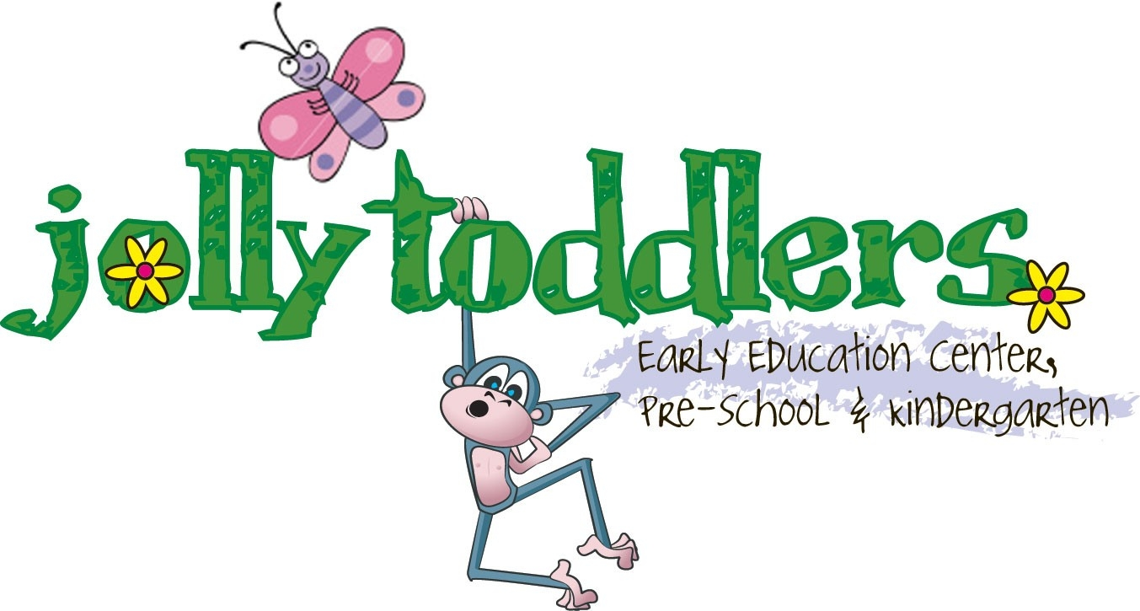

October 11, 2018

Dear Parents:
As part of the Every Student Succeeds Act, (ESSA), each school district is charged with implementing curriculum alignment, communication, professional development, partnership and transition activities with the early learning providers in their communities.
Each school district has requested a list of students by district including age, parents name, address and contact information to be provided by 10/30 this school year.
Please sign below indicating your approval for Jolly Toddlers to provide the district with this information as they prepare to welcome your child to their school in the upcoming school year.
Thank you,
Nancy Thompson, R.N.
Director

Child’s Name Date of Birth School District

________________________________________ ______________ ___________________

Parent Signature

_________________________________________________________________Date________________

Home Address Phone__________________________________

